

Email Marketing Application

Aim:

The aim of this project is to create a simple application for Email marketing using aws (amazon web services) cloud services.

Email marketing:

Email marketing is a powerful marketing channel, a form of direct marketing as well as digital marketing, that uses email to promote your business's products or services.

Amazon cloud services used for this project:

AWS S3:

S3 (Simple Storage Service) is a cloud storage solution offered by AWS (Amazon Web Services). It provides secure and scalable storage infrastructure for businesses to store, retrieve, and manage large amounts of data efficiently.

**AWS Lambda:**

AWS Lambda is a serverless computing service provided by Amazon Web Services (AWS). It allows developers to run code in response to events without provisioning or managing servers. This service scales automatically and charges based on the actual compute time used, making it cost-effective and highly scalable for a wide range of applications and workloads.

AWS IAM:

AWS Identity and Access Management (IAM) is a web service that helps you securely control access to AWS resources.

AWS SES:

Amazon Simple Email Service (SES) is a cloud-based email service that allows users to send and receive emails using email addresses and domains at a low cost.

AWS Event bridge:

Amazon EventBridge is a serverless event bus that offers real-time access to changes in data in AWS services, custom applications, and software as a service (SaaS) applications.

Step 1: creating a S3 bucket and upload a csv file and html file:

.csv file-this is a file in which verified emails will be placed along with first name:

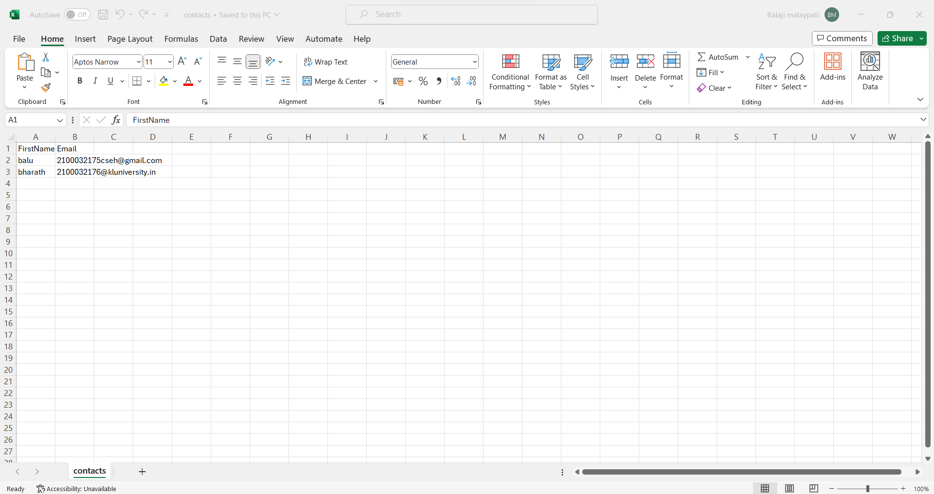

.html file-This html file is a example html file for email format, we can change this file according to our convenience(image of example template is):

S3 bucket after creating and uploading these files:

Step 2: create an AWS SES and verify the source email and create the identities for emails to which we want to send the emails:

After this an verification email send this email and we have verify in order to use it for email sending or receiving:

Now creating identities to the emails which we have to send the email.

Step 3: create a lambda function for merging or triggering the s3 bucket:

Write the lambda code for the project and include it in the newly created lambda function:

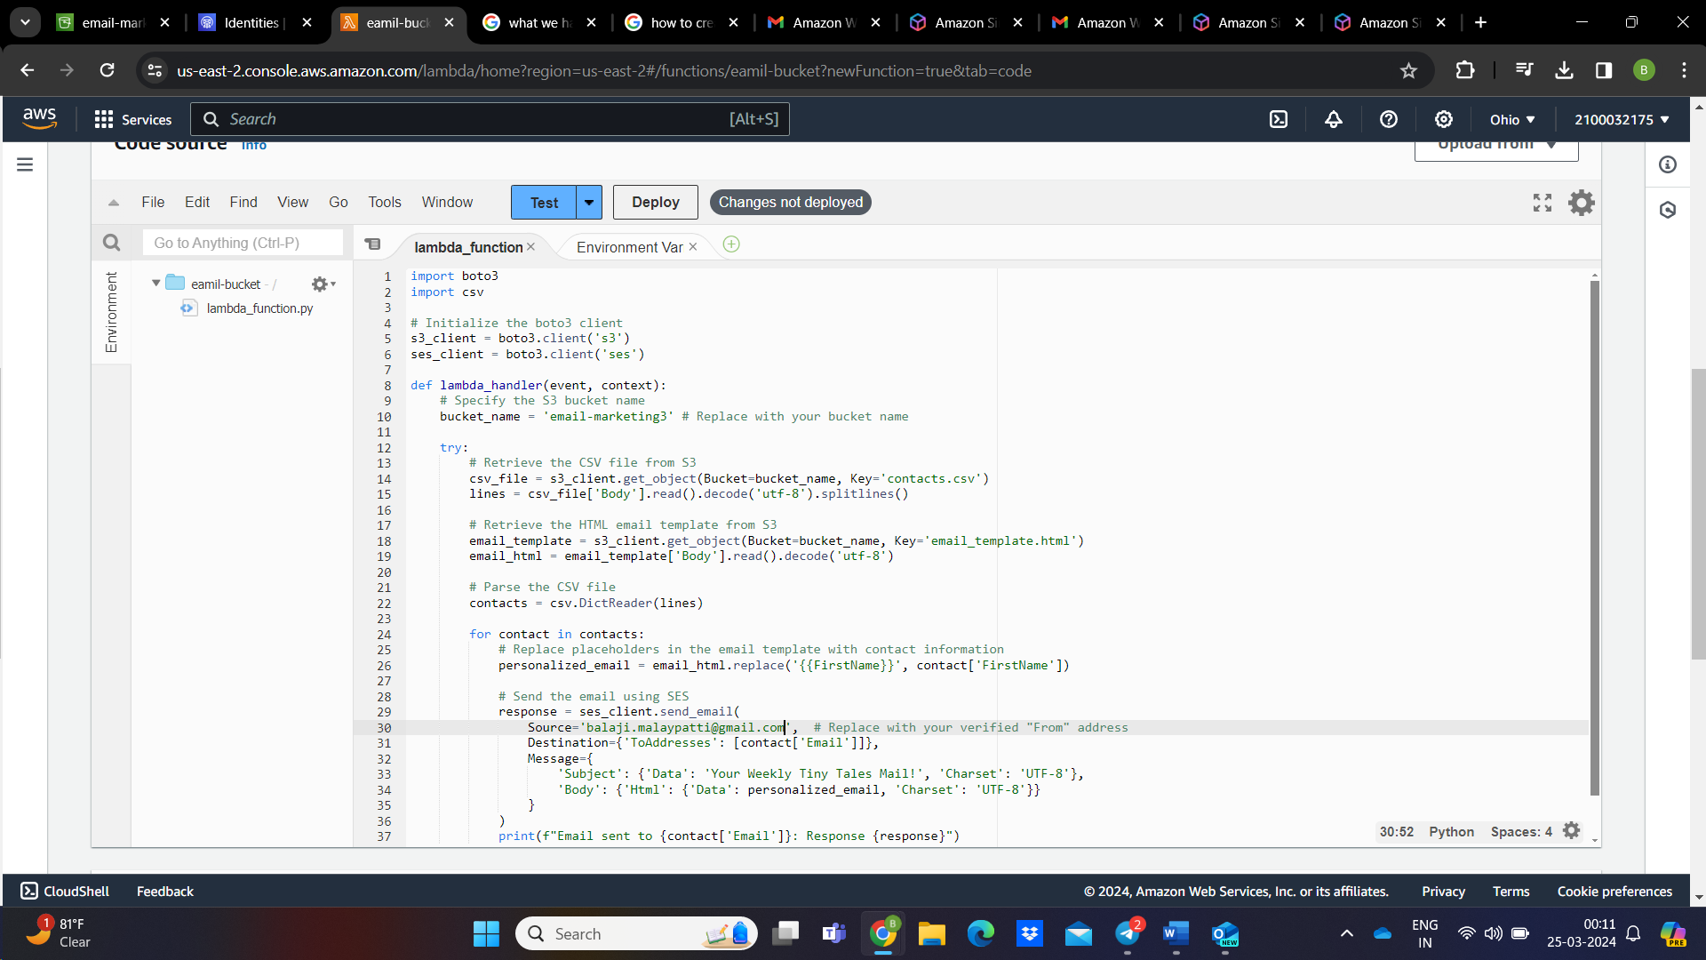

After clicking on the option deploy create a simple event configuration for testing the lambda code and click on test:

We will get errors because of not including IAM role properly and to correct the error we have create a IAM policy and attach that policy to the lambda function:

I have used a Json code to create a IAM policy and in that Json code I have included the permissions.

Now we won’t get any errors in the lambda code.

Step 4: create an EventBridge schedule in aws to select the timeline of the emails in the SES to be sent:

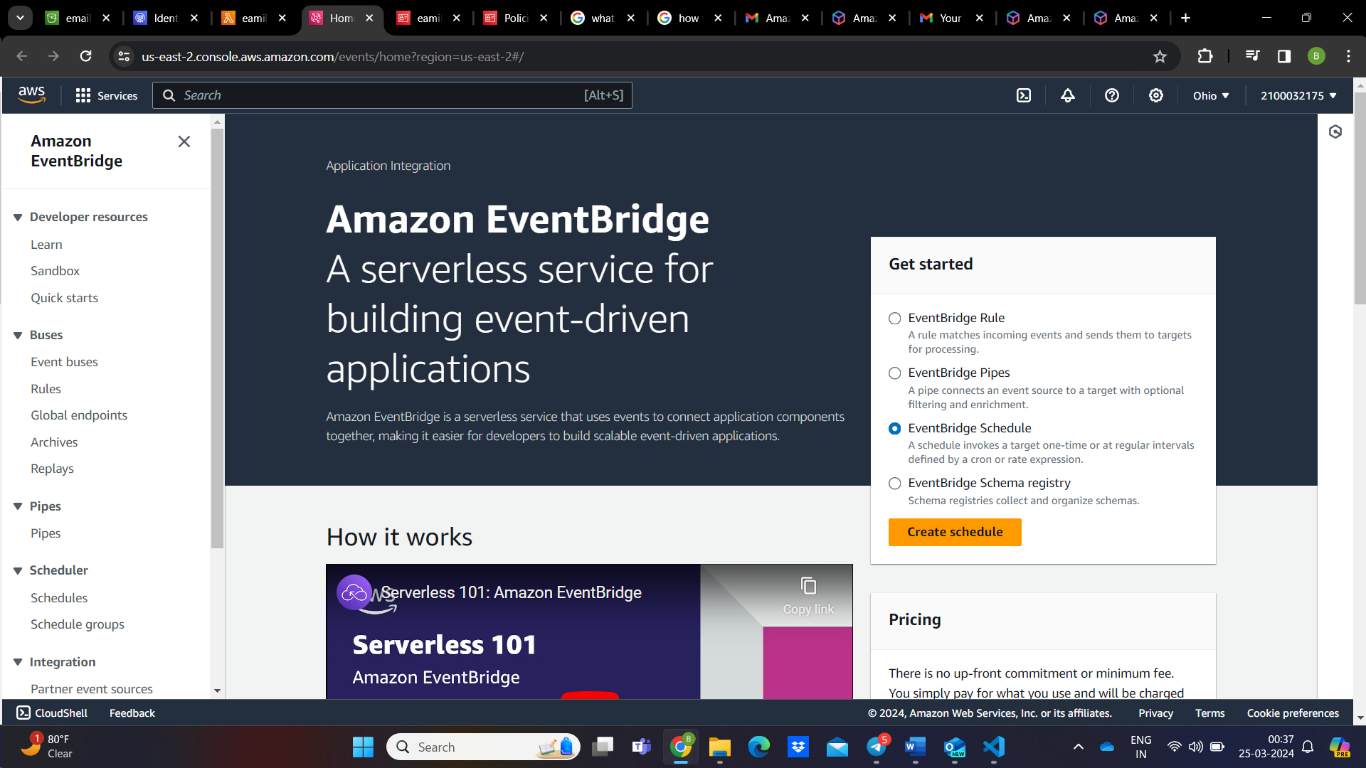

In the above options we have to select the date, time, Time zone for the email to be sent and we can also sent that emails after and after by selecting Recurring option

After that we have to select the service which we have to invoke for the above selected time for this project we are going to invoke the lambda

The time mentioned while creating the EventBridge schedule in aws in 12:44:

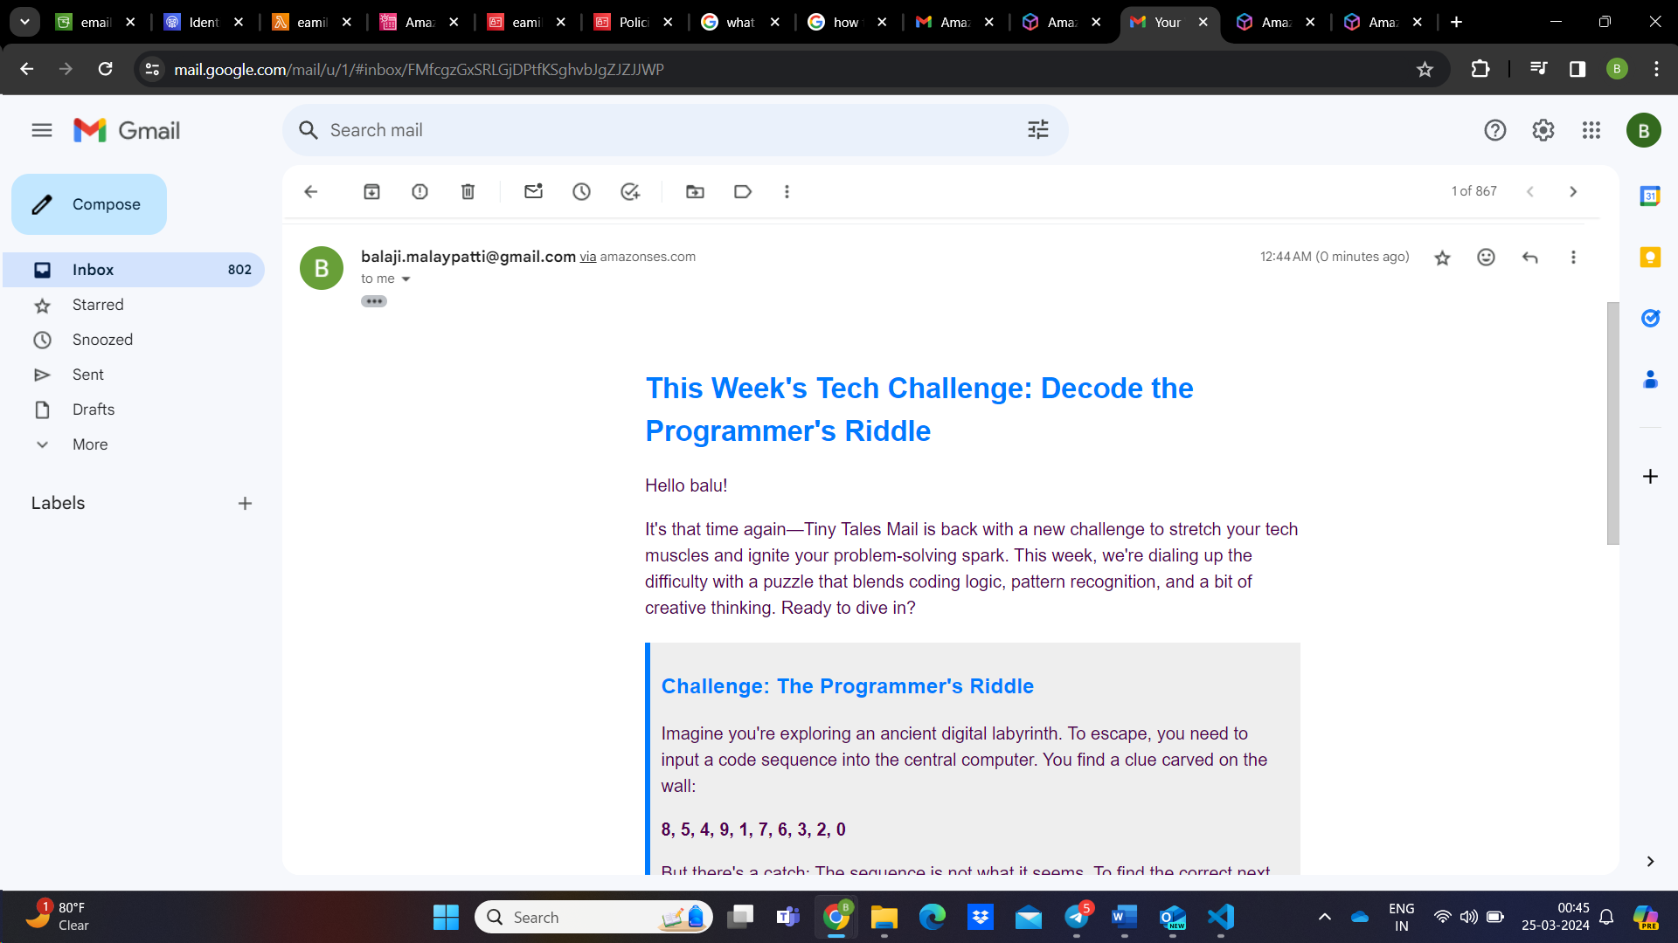

In lambda the monitor section we can see the lambda is triggered exactly the time we have selected:

We can also confirm that in the cloud watch logs by checking recent logs:

So by using simple Aws cloud services I created an applications for email marketing .We can receive emails by triggering lambda using EventBridge and using SES(Simple Email Service).